Week 7 Celebal Assignment
Databricks Notebook: Delta Lake MERGE Using Superstore Dataset
Step 1: Load Superstore Dataset
from pyspark.sql.functions import *
from delta.tables import DeltaTable
df = (
spark.read
.option("header", "true")
.option("inferSchema", "true")
.csv("/Volumes/week7/default/week7/Sample - Superstore.csv")
)
display(df)
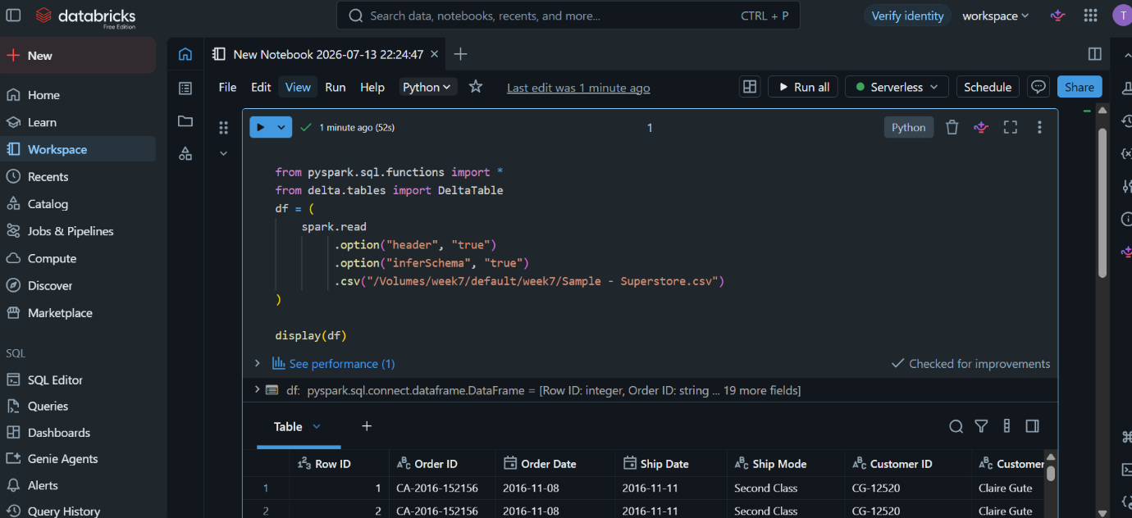
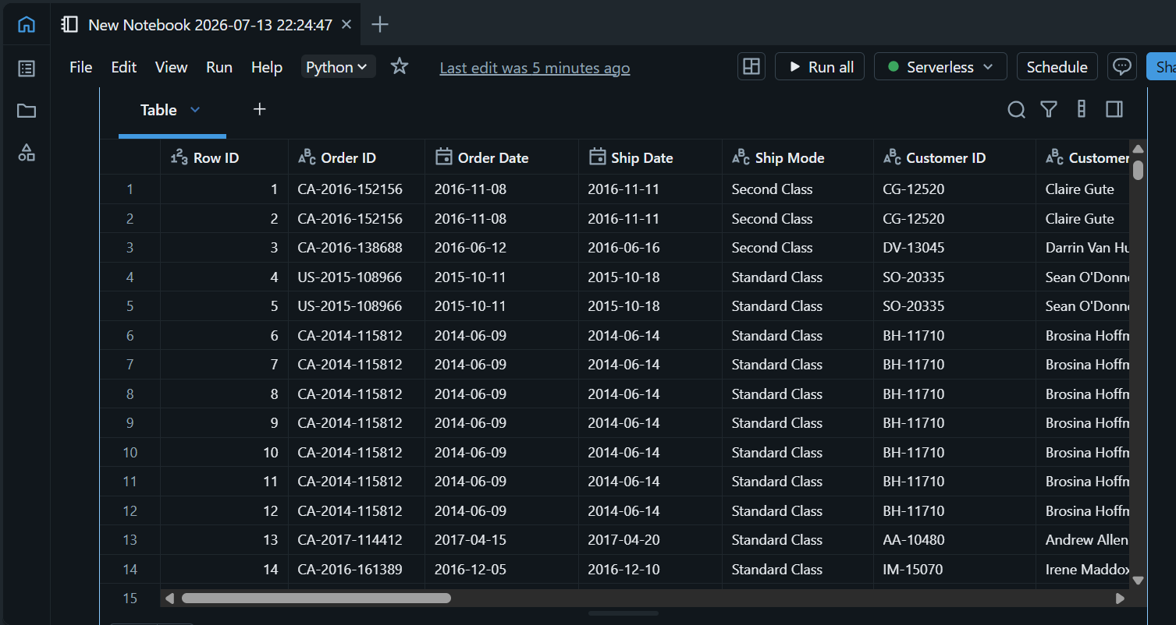
Step 2: Explore Dataset
print("Rows:", df.count())
print("Columns:", len(df.columns))
df.printSchema()
display(df.limit(10))
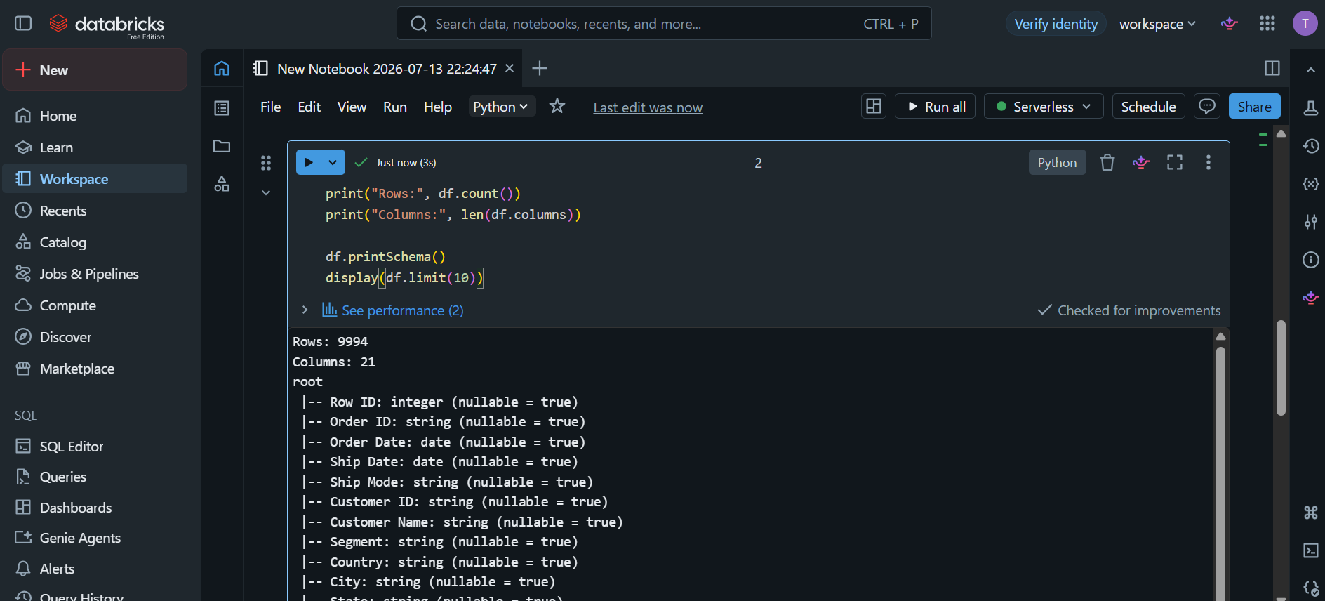
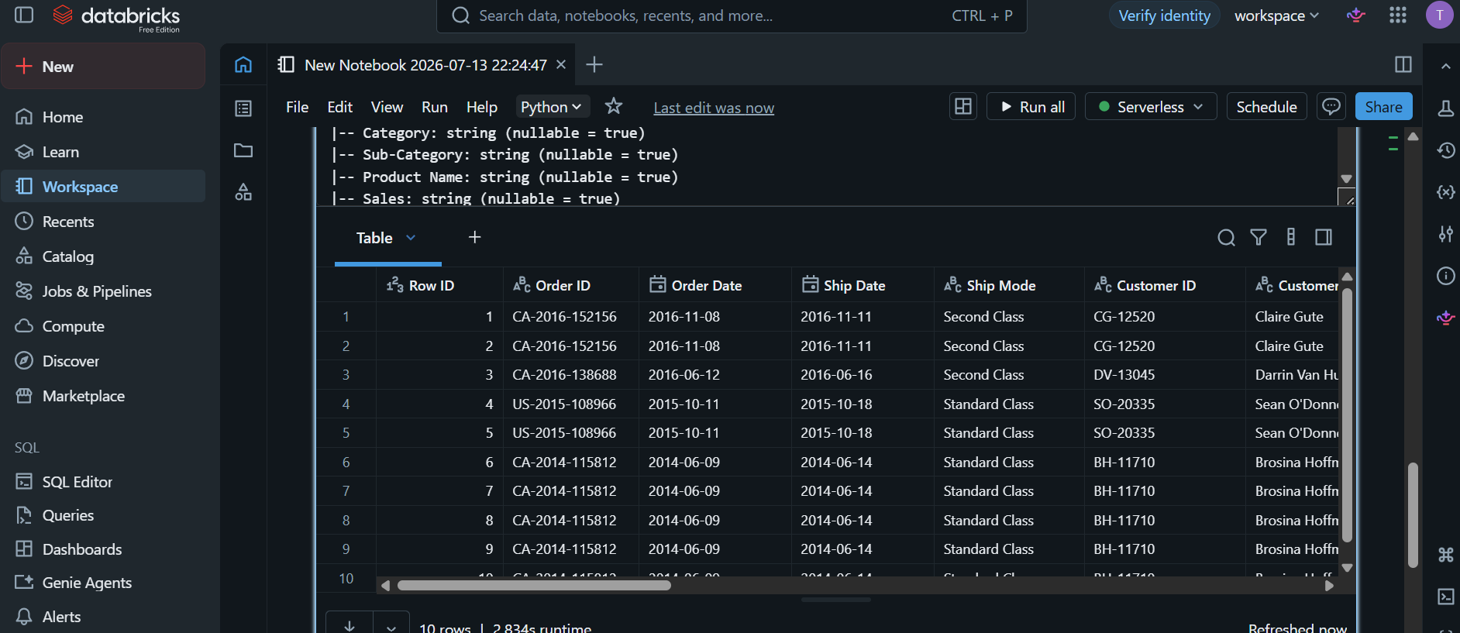
Step 3: Handle Missing Values
df = df.fillna({
"Postal Code": 0,
"Sales": 0,
"Quantity": 0,
"Discount": 0,
"Profit": 0
})
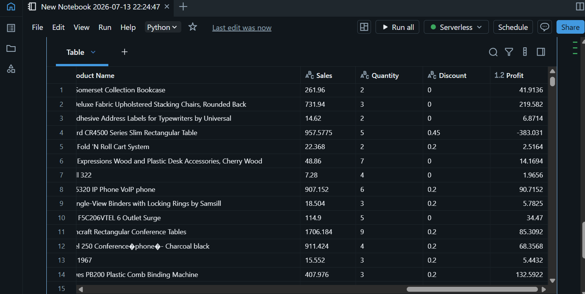
Step 4: Remove Duplicates
rows_before = df.count()
df = df.dropDuplicates()
rows_after = df.count()
print("Before:", rows_before)
print("After:", rows_after)
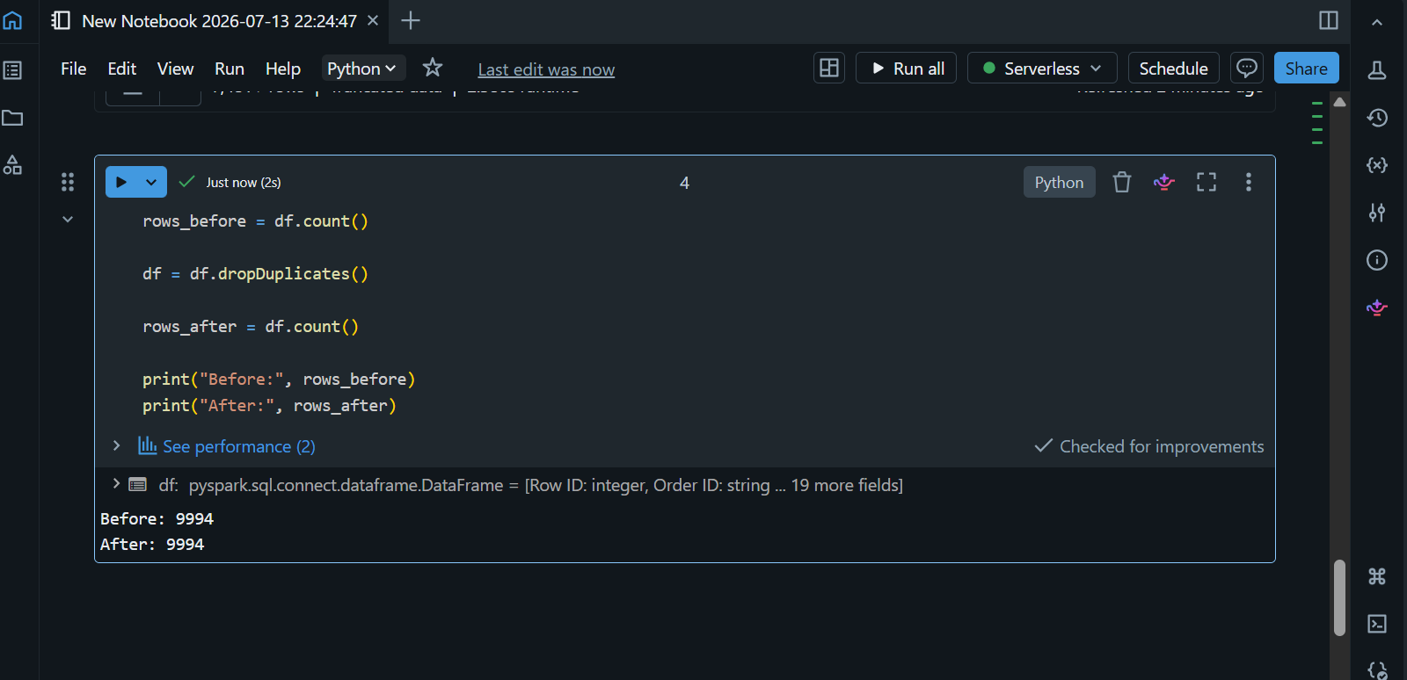

Step 5: Save as Delta Table
df.write.format("delta")
for col_name in df.columns:
new_name = (
col_name.replace(" ", "_")
.replace("-", "_")
.replace(".", "_")
)
df = df.withColumnRenamed(col_name, new_name)
display(df)
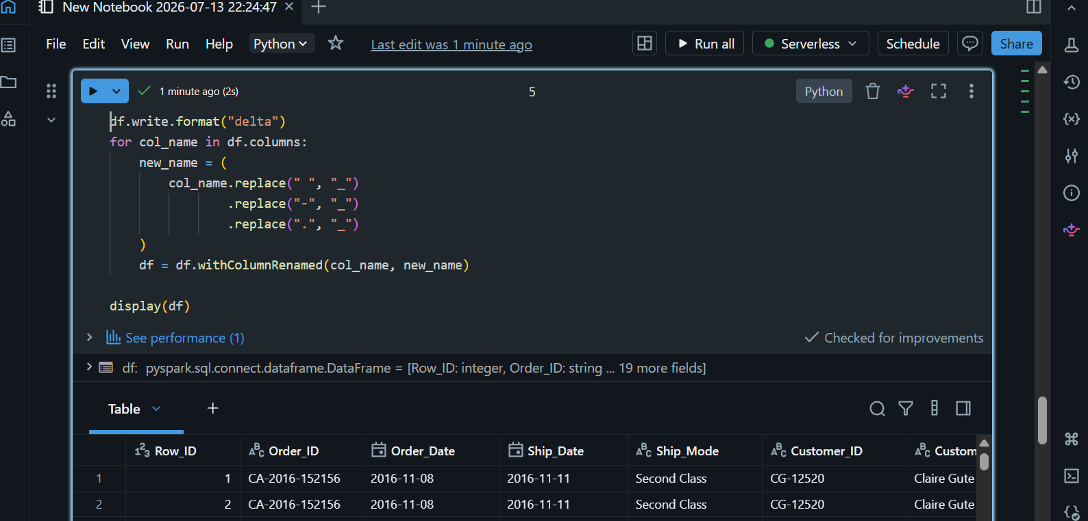
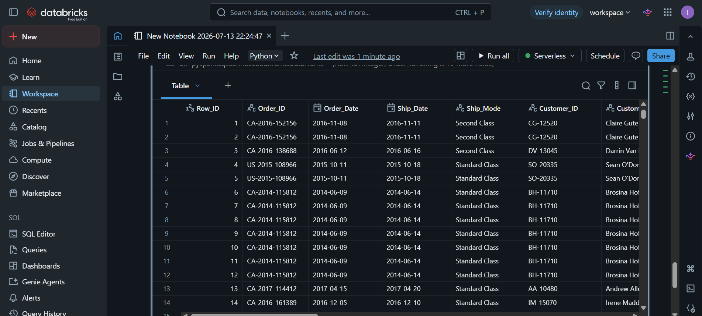
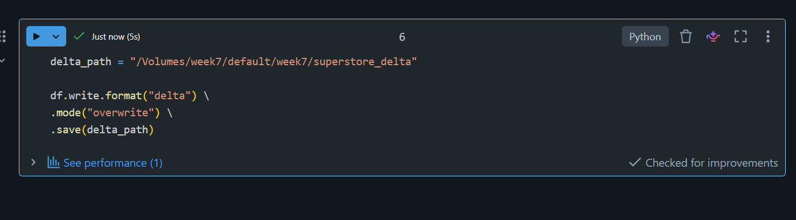
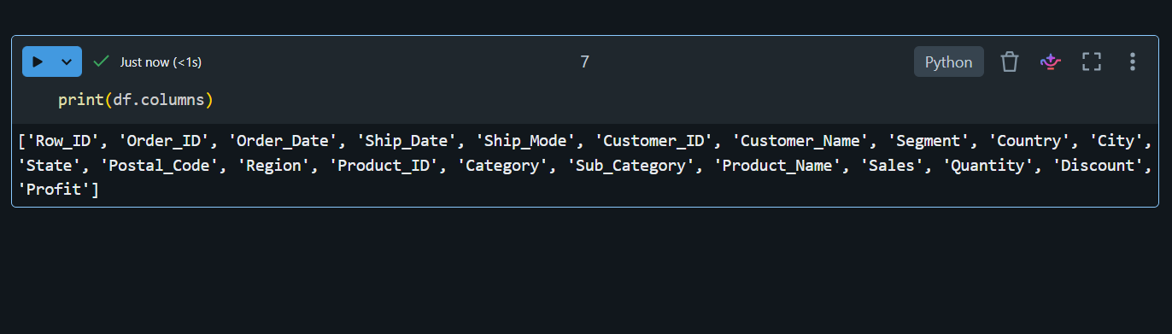
Step 6: Create Incremental Dataset
incremental_data = [
("CA-2017-152156","Second Class","CG-12520","Claire Gute","Consumer","United States","Kentucky","Henderson","42420","South","Furniture","Bookcases",300.00),
("CA-2017-138688","Second Class","DV-13045","Darrin Van Huff","Corporate","United States","California","Los Angeles","90036","West","Technology","Phones",500.00),
("NEW-10001","Standard Class","AB-10001","Amit Sharma","Consumer","India","Telangana","Hyderabad","500001","South","Technology","Laptops",950.00),
("NEW-10002","First Class","RS-10002","Ravi Kumar","Corporate","India","Karnataka","Bangalore","560001","South","Office Supplies","Binders",120.00)
]
columns = [
"Order ID","Ship Mode","Customer ID","Customer Name",
"Segment","Country","City","State","Postal Code",
"Region","Category","Sub-Category","Sales"
]
df_incremental = spark.createDataFrame(
incremental_data,
columns
)
display(df_incremental)

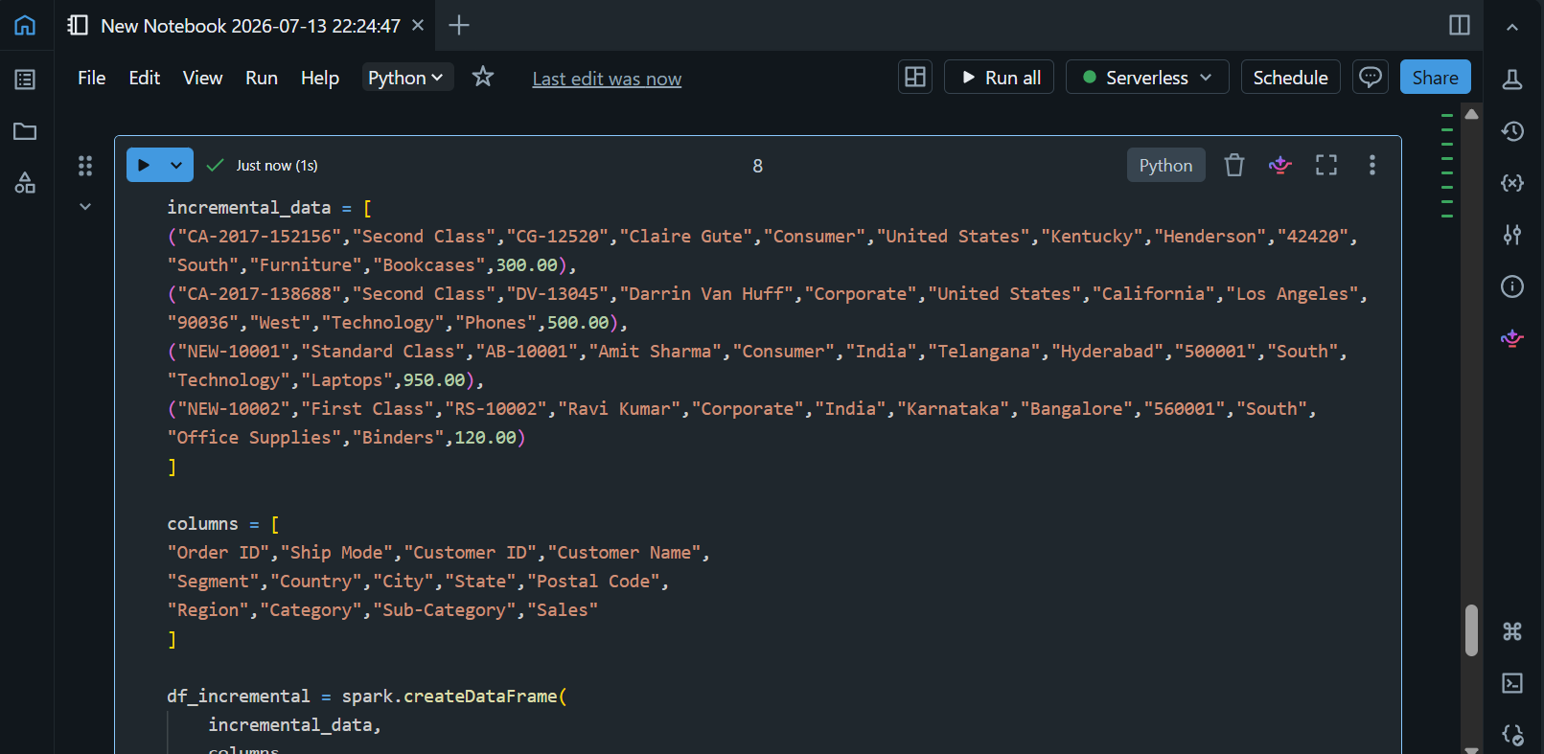
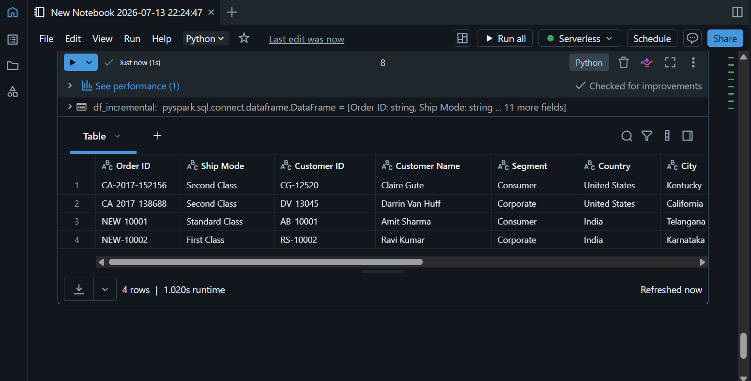
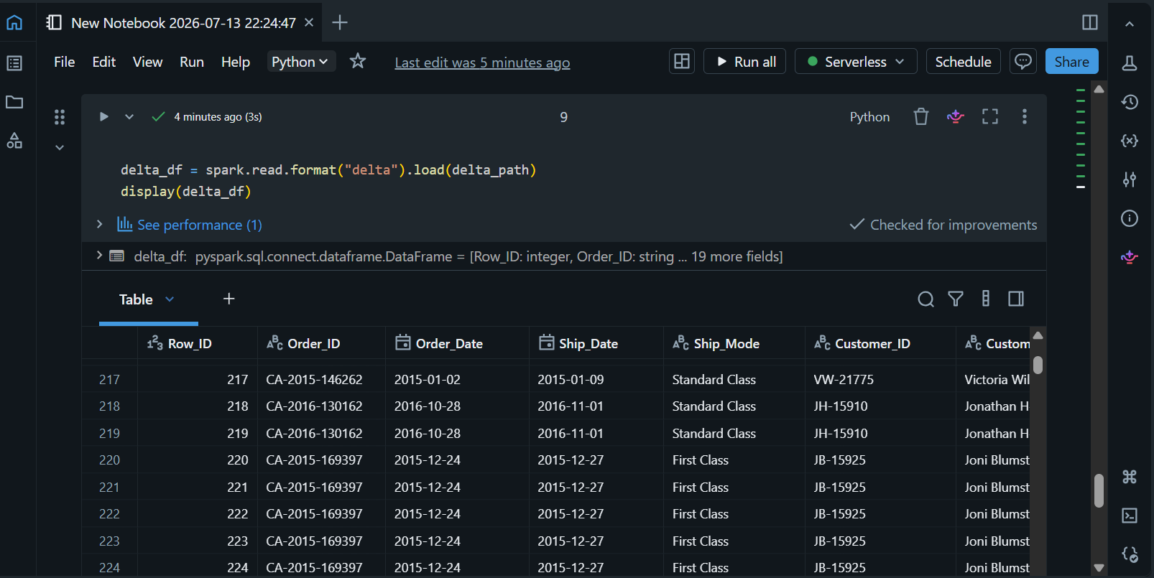
Step 7: Performing the MERGE Operation
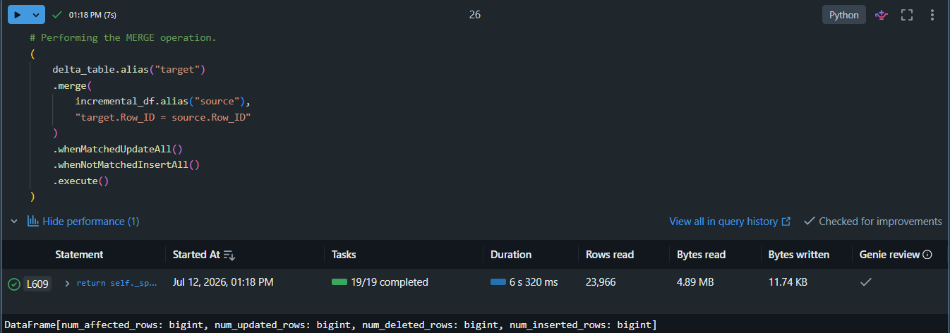
Step 7: Validating the Results
